**PESAH**

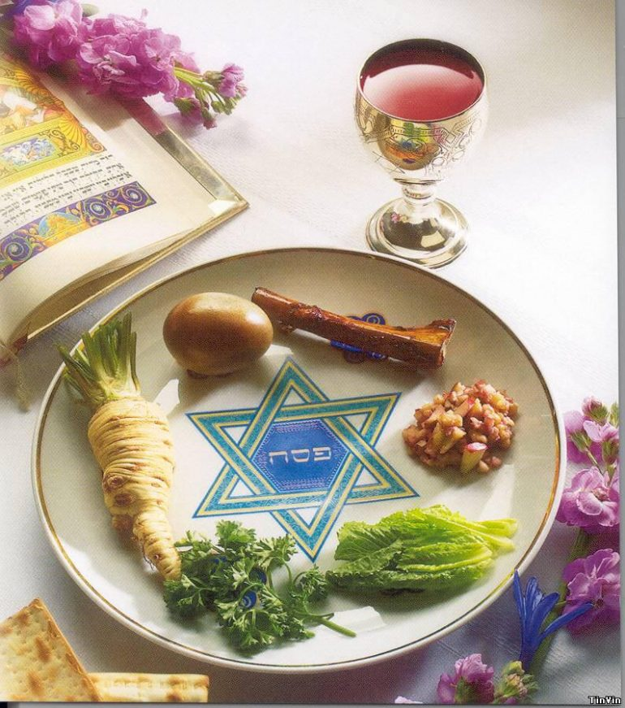

**Irrational actions**

At last. I received it. A call from my female friend. I am very happy to hear her voice. Since childhood, we were thick as thieves and a few weeks ago, she and her husband left for Israel. To live there. I miss her…

Her voice is ‘dim’.

“How are you? Go ahead, tell me!”

I expect something very bright, sunny.

“It’s okay…We have started the process of obtaining documents, live with the relatives at the moment. A mess, in short. Everything is going like clockwork here.”

“Not what you expected?”

“They get ready for Pesach here. All day long, they are busy washing and cleaning. Throw away all old things, scrape. And at that, talk only about it. Absolutely all of them. You know, I am getting annoyed at it now. I ask: what is it? What for? They answer: "It is the custom." Full stop.”

I try to reassure her, to support:

“There must be something….People cannot perform the same actions from generation to generation. Just like that. Without any meaning and understanding.”

“Well…They say so it is written in their books.”



It’s so characteristic of my friend Svetka! If something goes not the way she wants — it makes her indignant at once.

“Wait, wait, calm down…There is something very special about it…I think it should be explained to you so that you come to love them…It will be easier.”

I feel it is an important question. Rather, an answer. And for me too. And for everyone. It is important for us to understand this persistence — "it is the custom." Why, for the sake of what, so many generations of Israel performed and perform these irrational actions?

**Prophet**

The prophet Moses stood before the elders of Israel. Saying:

“We get used to humiliations by Egyptians. We get used to being slaves. Not just physically but mentally.   
A piece of bread and bedding matter more to us than freedom! Stop being slaves!”

“But Moses! We can incur pharaoh’s displeasure upon ourselves! We won’t be able to get away from him.”

“Stop being slaves! You try to find an excuse to avoid fighting!”

He knew the faces of slavery. Bestial, insidious, or fiercely angry…The total absence of dignity, responsibility — the qualities that distinguish a free man.

“You say you love the Creator? He demands from you to break free. So, obey!”

**Guiding star**

And what if we trust in the process? All that endless number of actions performed by us — for the sake of what?

All these automatic, repetitive movements.

Problems and troubles falling to our share…what is the purpose of them?

Where is the end of this slavery, in the dark of which we go and in which life happens to us?

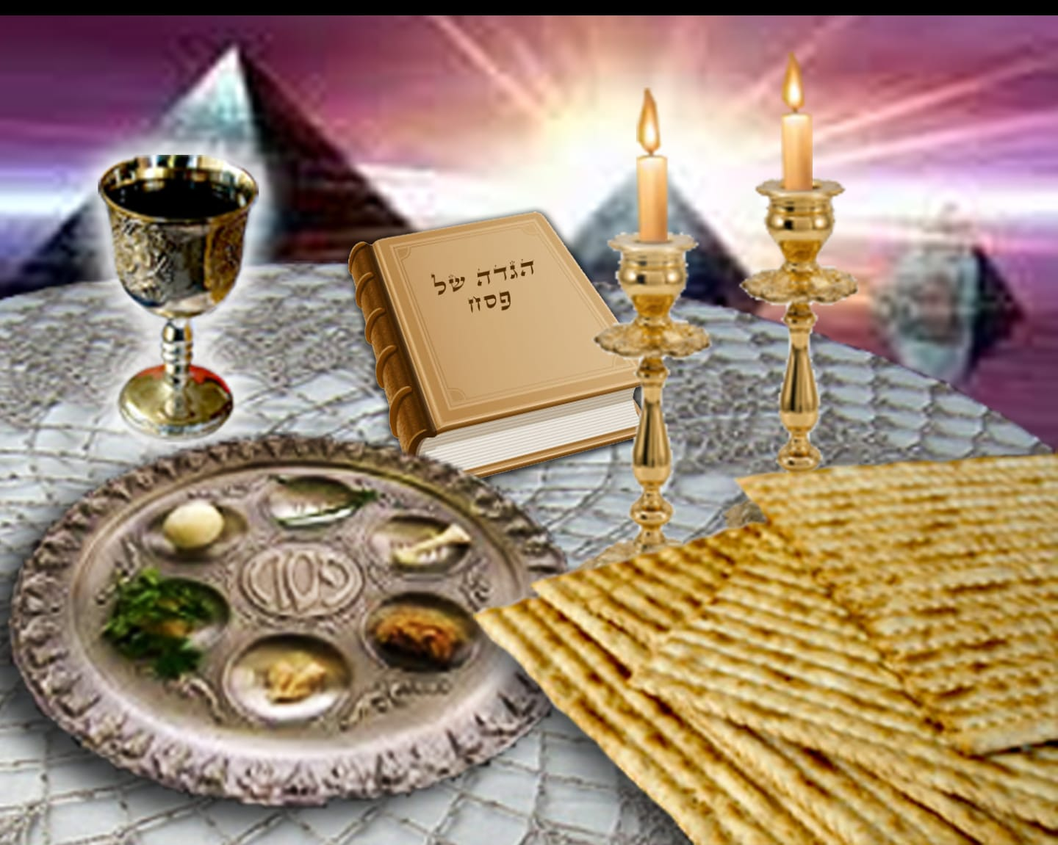

I remember those severe ordeals I underwent. Concerning both the health and the family. At such moments, you sense keenly that you drop from the usual life. Nothing is left. Total separation from reality.

You face a choice: ‘to lick’ the bleeding wounds and to curse everything or…And somewhere after this "or", freedom begins…We believe…Like a child who holds the mother’s hand, we hold a connection to this spark of faith. We follow it. Trust in the process…We let the Higher Power work.

It is this spark that becomes our Guiding star.

**Passover**

The Creator said to Moses: "Let the people of Israel follow Me. I will save them".

Obeying the order, Moses brought his people to the sea. The strongest wind blew…Heaving huge waves at the sea. The air was filled with sand and water. The sand was everywhere. It got in the eyes. Making it difficult to breathe.

“We have to pass over to the other side. Our rescue is there. Our life and freedom are there,” he said.

“But Moses. We can drown. It would be better for us to stay with Egyptians!”

The people did not trust. Neither in Moses nor in the Creator nor even in themselves.

“Guide us, give us the strength to follow You,” silently, with all his heart the Prophet pronounced.

The wind which has grown stronger was literally pushing Moses in the back. Darkness fell. Moses came to the sea and pointed with his staff to a place where water divided into two parts because of the wind.

“Here is our path to the other coast,” he said in a low voice.

The people do not move.

And then, an elder came out.

“Israelites, brothers! We are all one people, and we will prove it to Him Who directs us. We believe! We will follow Moses, he has already saved us many times; by his mouth, the Creator speaks to us!”

A young man stepped out of the crowd and confidently headed to the water. He was followed by the others.

They entered a narrow pass, a water parting. So clear and clean that even pebbles could be seen at the bottom.

The wind abated, and the sun lit the smooth sea surface. The people were rescued.

**Quantum leap**

To get out of slavery, one should reach the highest degree of despair. When we see that the Pharaoh, Amalek, our Ego — possesses us totally and we cannot even move a finger without self-profit. But we should ‘mature’ up to it. And these thousands of years of slavery, endless repetition of the same actions will eventually ‘fill up the cup’ when we are ready to exclaim. We are ready!

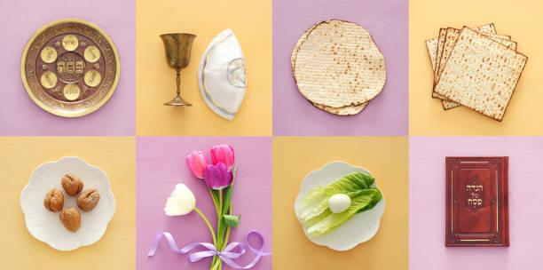

A hoarse sound coming from the heart. A silent whisper on the lips: "Help. Correct us. Give the strength to love".

This is another reality. That makes it difficult. Overcoming resistance everywhere.

And then, we do it … PASSOVER. PE-SAH.

The first contact with the system of the Creator.

Inside us, there is already the beginning of faith in that only He can help us make this quantum leap from a pharaoh’s slave to a man. The man becomes free when he realizes how much he is interrelated with other people and that his happiness depends on the extent to which he can improve these relations with each one of them.

To come nearer to "Quantum leap", the exit to another reality, we clean our house. Meaning and realizing that in this way, we clean our heart. From everything which prevents it from making the only right movement.

When I finished writing this letter, it was already late. I hit the "Send" button. And went to bed.

And in the morning, barely awake, I saw a voice message from her.

“Ira thanks. I had no idea…And I got it.”

She did not finish speaking. She knew I would understand her. Without words.